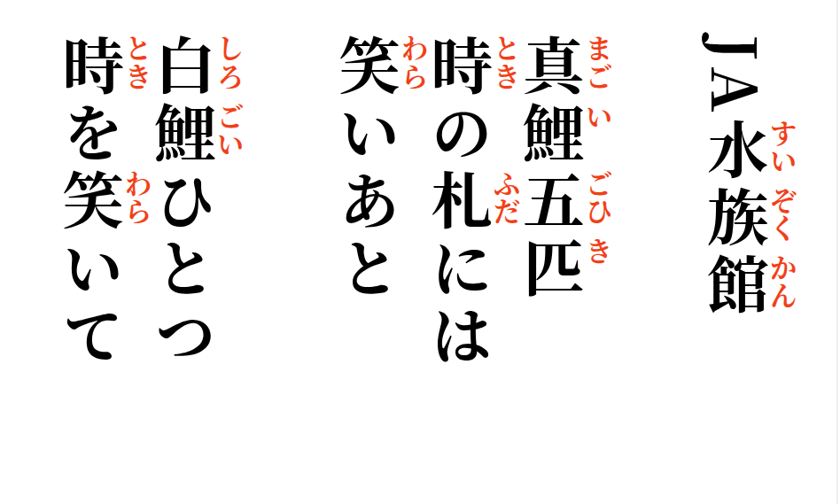

2026-09-11
JA Aquarium

Five black carp—
on their time cards,
traces of laughter.

One white koi
smiles at time.

